User: [amir@admin.com](mailto:amir@admin.com)

Errand request for employee gol jenabi: 09122078278 {ER432020}

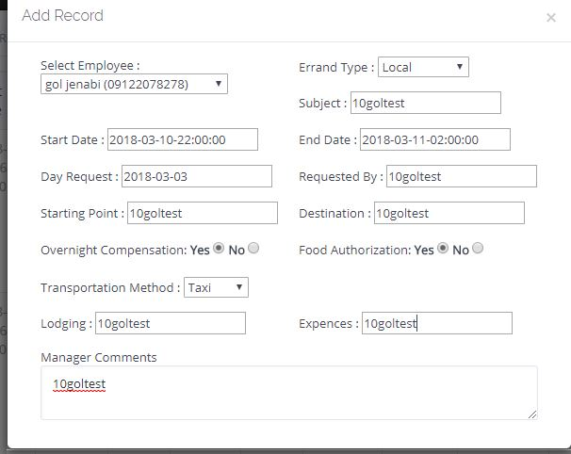

As you can see, I entered 2200-0200 (4 hours total) on march 10/11 but the total duration lists as 00:00



Now the strange part is here, I logged on with: [anal@lee.com](mailto:anal@lee.com) and entered the same exact request for employee anal: (ER907140)

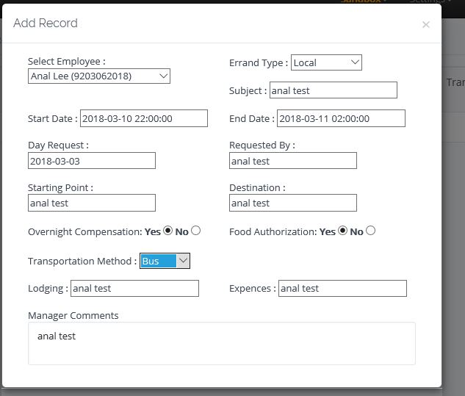

Only for that to properly do the math..(4hrs)



Hardik this is terrifying man, terrifying…..

Not only do our app and portal engines work separately but different users, yield different results?

I really, honestly am at a loss of words..